
SMART QUIZ SYSTEM
Complex Computing Activity (CCA)
Object Oriented Programming in C++

GROUP MEMBERS:
SADIA AMIR(CT-157)
MIFRAH IQBAL(CT-172)
FAIZAN KHAN (CT-195)

NED University of Engineering & Technology
Department of Computer Science & Information Technology

1. Introduction
The Smart Quiz System is a console-based C++ application developed using Object-Oriented Programming concepts.
The system allows users to attempt quiz questions, check answers, calculate scores, and save results in a leaderboard file.
This project demonstrates the practical implementation of OOP principles and software engineering techniques.
The project was designed to fulfill the requirements of the Complex Computing Activity (CCA).
It uses advanced concepts such as inheritance, polymorphism, abstraction, templates, STL containers, exception handling,
file handling, and design patterns like Singleton and Factory Pattern.

2. Objectives
- Develop a real-world quiz application using C++.
- Implement all major OOP concepts.
- Use file handling for data storage.
- Implement design patterns.
- Create modular and reusable code.
- Build an interactive console interface.

3. OOP Concepts Used
Encapsulation: Data members and methods are combined inside classes like Question and QuizManager.
Inheritance: MCQ class inherits properties from Question base class.
Polymorphism: Virtual function display() is overridden in derived classes.
Abstraction: Question class contains pure virtual functions.
Composition: QuizManager contains vector<Question*> question bank.

4. Technical Features
- Singleton Pattern 5. File Handling
- Factory Pattern 6. Exception Handling
- Template Function 7. ASCII Graphics
- STL Vector

5. UML Class Diagram

The UML diagram shows relationships between classes used in the Smart Quiz System.
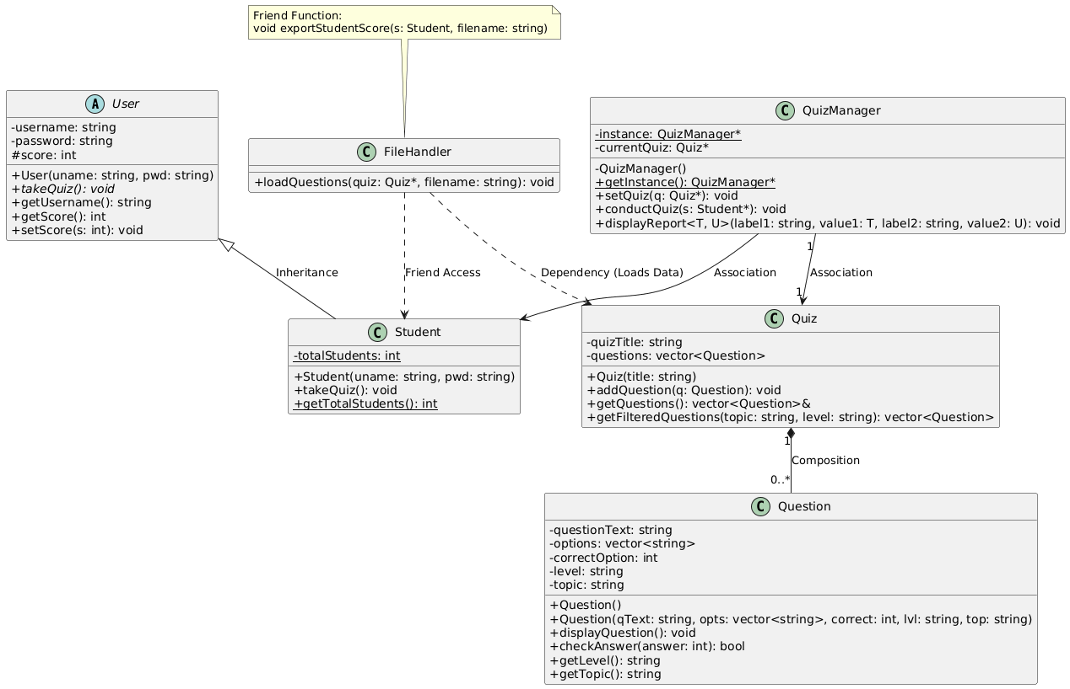

Implementation of OOP Concepts
Encapsulation:
Explanation: We achieved encapsulation in the User class by declaring sensitive data (username, password, score) as private. They cannot be accessed directly from outside the class. To read or modify them, we provided controlled public getter and setter methods, ensuring data security.
class User {
private:
string username; // Private: Cannot be accessed directly
int score;
public:
// Controlled public access via Getters and Setters
string getUsername() const { return username; }
void setScore(int s) { score = s; }
};

Inheritance:
Explanation: The Student class inherits from the User base class using the public access specifier. This allows Student to reuse the properties (username, score) and methods of User, promoting code reusability.
// Student inherits publicly from User
class Student : public User {
private:
static int totalStudents;
public:
Student(string uname, string pwd) : User(uname, pwd) {
totalStudents++;
}
};

Polymorphism:
Explanation: Runtime polymorphism is implemented using virtual functions. The User class defines a pure virtual function takeQuiz(), making it an abstract class. The Student class overrides this function to provide its specific implementation.

class User {
public:
// Pure Virtual Function (Abstraction + Polymorphism)
virtual void takeQuiz() = 0;
};
class Student : public User {
public:
// Overriding the base class function
void takeQuiz() override {
cout << "Student " << getUsername() << " is taking the quiz..." << endl;}};
Static Members:
Explanation: We used a static integer totalStudents inside the Student class. A static member shares the same memory across all objects of the class, allowing us to keep a global count of how many students are created
// In Student.h
static int totalStudents;

// In Student.cpp (Initialized to 0)
int Student::totalStudents = 0;

// Inside Student Constructor
Student::Student(string uname, string pwd) : User(uname, pwd) {
totalStudents++; // Increments shared static count
}

Friend Functions:
Explanation: The exportStudentScore function is declared as a friend inside the FileHandler class. This grants the function special permission to access the private and protected members (like username and score) of the Student class directly for file writing.

class FileHandler {
public:
// Declaring friend function
friend void exportStudentScore(const Student& s, const string& filename);
};

// Friend function accessing private data
void exportStudentScore(const Student& s, const string& filename) {
ofstream outFile(filename, ios::app);
outFile << "Student: " << s.getUsername() << " | Score: " << s.getScore() << "\n";
}
Object Relationships (Composition & Aggregation)
Explanation:
- Composition: A Quiz is composed of Question objects. If the Quiz is destroyed, its Question objects are also destroyed.
- Aggregation: QuizManager associates with Quiz and Student, but they can exist independently outside the manager.

class Quiz {
private:
vector<Question> questions; // Composition: Quiz "has-a" Questions
public:
void addQuestion(Question q) { questions.push_back(q); }
};
Templates & STL (With Code Explanations)
Templates
Explanation: We implemented a template function displayReport in QuizManager. This allows a single function definition to handle different data types (e.g., string for the student name and int for the score) without writing separate overloaded functions.

// Template definition with two generic types T and U
template <typename T, typename U>
void QuizManager::displayReport(const string& label1, T value1, const string& label2, U value2) {
cout << label1 << ": " << value1 << endl; // Can print string
cout << label2 << ": " << value2 << endl; // Can print int
}

STL Containers & Algorithms
Explanation: We used std::vector (an STL dynamic array) to store multiple Question objects and options. We also utilized std::transform from the <algorithm> library to convert user input to lowercase for error-free matching.

vector<Question> questions; // STL Vector usage
// STL Algorithm for string manipulation
string chosenLevel;
transform(chosenLevel.begin(), chosenLevel.end(), chosenLevel.begin(), ::tolower);

Error & Exception Handling (With Code Explanations):
Explanation: The system uses C++ try/catch blocks to handle invalid user inputs gracefully. If a user enters a letter instead of a number, or selects an out-of-bounds option, the program catches the exception and prevents a crash.
try {
if (cin.fail()) {
cin.clear();
cin.ignore(numeric_limits<streamsize>::max(), '\n');
throw invalid_argument("Invalid input! Please enter a number.");
}
if (answer < 1 || answer > 4) {
throw out_of_range("Answer must be between 1 and 4.");
}
} catch (const exception& e) {
ConsoleGUI::showError(string(e.what()) + " Marked as wrong.");
}

File I/O Operations (With Code Explanations)
Explanation: File handling is used for persistent storage. std::ifstream reads the questions.txt file to dynamically load quiz data, and std::ofstream writes student scores to scores.txt in append mode.

// Reading from file
void FileHandler::loadQuestions(Quiz* quiz, const string& filename) {
ifstream inFile(filename);
// Parsing logic to read delimited text...
}

// Writing to file (Append mode)
ofstream outFile("scores.txt", ios::app);
outFile << "Student: " << s.getUsername() << " | Score: " << s.getScore() << "\n";

Design Pattern (With Code Explanations)
Singleton Pattern:
QuizManager Explanation: The Singleton pattern ensures that a class has only one instance and provides a global point of access to it. We implemented this in QuizManager to ensure only one engine controls the quiz flow at a time.

class QuizManager {
private:
static QuizManager* instance;
QuizManager() {} // Private constructor

public:
// Static access method
static QuizManager* getInstance() {
if (instance == nullptr) {
instance = new QuizManager();
}
return instance;
}
// Delete copy constructor to prevent duplication
QuizManager(const QuizManager&) = delete;
};

13. Advantages of the System

- Easy to maintain
- Reusable and modular code
- Interactive user interface
- Expandable for future features
- Demonstrates professional coding practices

14. Future Enhancements
- Add timer-based quizzes
- Add graphical user interface
- Add database connectivity
- Add multiplayer functionality
- Add categories and difficulty levels

15. Conclusion
The Smart Quiz System successfully demonstrates the practical implementation of Object-Oriented Programming concepts in C++.
The project fulfills all technical requirements mentioned in the Complex Computing Activity guidelines.
The use of design patterns, templates, file handling, inheritance, and polymorphism makes the system efficient, scalable, and maintainable.
This project provides a strong example of software engineering principles and real-world problem solving using C++.

